Trapped by Stability: A Falsification Framework for Acquisition-Driven Radiomic Phenotypes

Abstract
This study does not report a new breast MRI radiomic phenotype. Instead, it shows how a phenotype claim can fail despite conventional internal validation, a failure mode we term the stability trap: a cluster may be reproducible under resampling and exhibit a seemingly meaningful prognostic signal, while lacking biological identity. In a 922-patient multi-vendor breast MRI cohort, a standard unsupervised workflow produced the kind of result that can be overinterpreted: a stable two-cluster partition with enhancement-dominant, vascularity-like feature differences and an unadjusted recurrence-free survival signal in HR+/HER2+ disease. We treat this result as a falsification case rather than a biomarker candidate.
The raw partition was strongly aligned with scanner manufacturer and pulse-sequence structure, whereas molecular subtype and whole-cohort recurrence were not robustly associated with the cluster labels. Leading variance axes were more strongly associated with TR, TE, acquisition matrix, and manufacturer than with molecular subtype. After manufacturer adjustment, the HR+/HER2+ survival signal weakened. Manufacturer residualization and ComBat harmonization preserved internal clusterability but replaced the original patient partition, with ARI versus the raw labels of approximately 0.06 to 0.07.
The post-harmonization structure was cleaner but not biologically validated. It was more strongly associated with tumour size than with recurrence or subtype, did not improve prediction beyond clinical covariates, and did not satisfy prespecified biomarker criteria. The main contribution of this study is methodological: we propose a falsification framework for radiomic phenotype claims. The framework includes multi-condition discovery, harmonization sensitivity, within-vendor sanity checks, and continuous vendor-clean scoring as minimum checks for multi-vendor MRI, multicenter radiomics, and imaging-AI studies in which technical variance can masquerade as biology.
Keywords
Breast MRI; radiomics; phenotype discovery; ComBat harmonization; acquisition confounding; cluster stability; cluster identity; imaging AI reproducibility.

Table 1. The falsification framework proposed as a minimum standard for radiomic phenotype claims.
Check | Operational question | Required reporting output | Failure mode detected
1. Multi-condition discovery | Does the phenotype persist under raw, redundancy-reduced, harmonized, and vendor-restricted conditions? | Cluster labels, bootstrap ARI, ARI/NMI versus raw labels, and cluster validity metrics. | A stable cluster that depends on one preprocessing or acquisition domain.
2. Harmonization sensitivity | Does the headline clinical association retain direction and magnitude after residualization, ComBat, and manufacturer adjustment? | Side-by-side Cox HRs, confidence intervals, p-values, and AUC changes across harmonization variants. | A prognostic signal that is an artifact of acquisition coupling.
3. Within-vendor sanity check | Can a known biological association be recovered when scanner/vendor heterogeneity is removed by restriction? | Vendor-stratified effect estimates for a positive-control biological contrast. | A pipeline that cannot recover biology once technical variance is controlled.
4. Continuous vendor-clean score | Does a continuous score from candidate biological features remain orthogonal to vendor and clinically informative? | Association with manufacturer/TR/TE, endpoint association, and incremental value over clinical covariates. | A cluster that is stable but lacks a vendor-independent biological axis.

1. Introduction
Radiomic phenotype discovery aims to identify latent imaging subgroups that may refine clinical or molecular classification in cancer. In breast MRI, dynamic contrast-enhanced imaging and related sequences generate quantitative descriptors of tumour morphology, vascularity, cellularity, and heterogeneity that can be interrogated using unsupervised learning. In principle, a stable cluster structure may suggest that imaging captures biologically meaningful variation beyond standard receptor-based subtype labels (Lambin et al., 2012).
That inference is far less secure in multi-vendor cohorts. Radiomic features are shaped not only by tumour biology but also by manufacturer, pulse-sequence parameters, field strength, voxel geometry, reconstruction choices, and acquisition timing (Zwanenburg et al., 2020). In high-dimensional settings, even modest acquisition effects can accumulate into dominant latent axes after dimensionality reduction, allowing clustering algorithms to recover stable partitions that reflect scanner-domain structure rather than biology. Standard internal validation metrics such as silhouette score and bootstrap stability assess reproducibility, but they do not distinguish a biological phenotype from a technically induced one (Handl et al., 2005). Relying on these metrics blindly creates what we term the "stability trap": the mathematical illusion that a data partition is biologically valid simply because its underlying technical artifact is highly stable and reproducible.
This distinction motivates the present study. Rather than treating unsupervised cluster discovery as a direct route to phenotype identification, we frame the analysis as a falsification chain. We first ask whether a conventional radiomics workflow produces a stable phenotype signals with interpretable feature differences and an apparent prognostic signal. We then test whether that finding survives a sequence of acquisition-aware challenges designed to expose technical confounding.
The first step evaluates the raw radiomic feature space. We assess whether the dominant principal components are more closely aligned with biological variables, such as molecular subtype, or with technical acquisition variables, including manufacturer and pulse-sequence parameters. The second step tests cluster identity itself. If the raw phenotype is biologically meaningful, technical correction should attenuate or refine the partition rather than replace it entirely. We therefore repeat phenotype discovery after manufacturer residualization and ComBat harmonization and compare the resulting partitions with the original raw cluster labels. The third step evaluates clinical interpretation. A putative prognostic phenotype should retain a consistent association with recurrence-free survival after adjustment for manufacturer and across harmonization strategies.
Using this framework, we re-examine a cohort of 922 breast MRI patients. A standard unsupervised pipeline initially identifies a stable two-cluster radiomic phenotype with enhancement-dominant, vascularity-like characteristics and an apparent HR+/HER2+ recurrence-free survival signal. Subsequent falsification analyses indicate that the leading variance axes are dominated by acquisition parameters, the raw cluster partition is strongly associated with manufacturer, and the apparent prognostic signal is not robust to technical adjustment. The contribution of this study is therefore methodological rather than biomarker-driven: it shows that a phenotype can be internally stable, visually interpretable, and apparently prognostic while still failing tests of biological identity.

2. Background and Rationale

Radiomic phenotype discovery
Radiomics is premised on the idea that routinely acquired medical images contain quantitative information about tumour phenotype that is not fully captured by visual interpretation. Early radiomics studies positioned image-derived features as a bridge between medical imaging, tumour heterogeneity, and personalized medicine, arguing that high-throughput descriptors can complement histology, genomics, and clinical covariates in risk stratification and treatment selection (Lambin et al., 2012). Breast MRI is a particularly relevant setting for this framework because dynamic contrast-enhanced MRI, diffusion-weighted imaging, T2-weighted imaging, and enhancement kinetics provide complementary information on vascularity, cellularity, morphology, and tissue heterogeneity (Pinker et al., 2018).
Beyond supervised prediction, radiomics has increasingly been used for unsupervised phenotype discovery. In this setting, patients are clustered directly in feature space, and the resulting groups are evaluated for associations with prognosis, molecular subtype, immune state, stromal composition, or pathway activity [Li et al 2018]. This strategy has been used to propose imaging-derived subtypes in breast cancer and other malignancies, including studies linking unsupervised clusters to survival, molecular pathways, and treatment response (Yamamoto et al., 2012) (Aerts et al., 2014)Collectively, this literature supports the possibility that radiomic clusters may capture clinically meaningful biological variation (Gillies et al., 2016).
Supervised versus unsupervised settings
The key methodological difference is that unsupervised clustering is exposed to a failure mode that supervised prediction partially avoids. In supervised radiomics, the outcome label is external to the imaging feature space, so performance can be judged against a predefined endpoint such as molecular subtype, recurrence, or treatment response. Technical confounding can still inflate apparent performance, but the model remains constrained by an external target and evaluated using metrics such as AUC, calibration, or survival statistics (Parmar et al., 2015). This partly explains why supervised radiomics has advanced toward clinical validation, whereas unsupervised phenotype discovery remains more vulnerable to interpretive ambiguity (Park et al., 2020)
Unsupervised discovery has no such external anchor. Cluster labels are created from the same feature space that may already contain scanner, protocol, or manufacturer effects. If technical variation explains more structure than biology, clustering algorithms may recover hardware-defined partitions before they encounter tumour-defined ones. Internal validation metrics such as silhouette score and bootstrap stability then measure whether a partition can be reproduced, not whether it corresponds to a true biological phenotype (Handl et al., 2005). This creates what we term the stability trap: mathematical reproducibility can be mistaken for biological validity.
Technical variance in radiomics
Radiomic features are sensitive to acquisition, reconstruction, discretization, resampling, segmentation, and scanner effects. Prior studies have shown that inter-scanner variability can materially alter radiomic features, that voxel size and gray-level discretization matter, and that many features are nonreproducible or redundant under acquisition variation (Berenguer et al., 2018) (Mackin et al., 2015) [(Duron et al., 2019) (Leijenaar et al., 2015). Broader reviews have concluded that reproducibility remains a major barrier to generalizable radiomics, motivating standardization efforts such as the Image Biomarker Standardisation Initiative (Zwanenburg et al., 2020) (Traverso et al., 2018).
MRI poses an even greater challenge because intensities are not inherently standardized across vendors, coils, pulse sequences, and protocols (Nyúl & Udupa, 1999). In breast DCE-MRI, enhancement-based features can reflect both vascular biology and acquisition-dependent signal behavior (Bhooshan et al., 2010). One of the clearest empirical warnings comes from multi-vendor, multi-parametric breast MRI radiomics, where mathematically derived features predicted the originating scanner platform and field strength with AUC values between 0.91 and 1.00 (Doran et al., 2021). Crucially, this technical classification performance heavily outstripped the pipeline’s ability to decode actual tumor biology, which achieved a cross-validated AUC of only 0.673 for predicting pathological nodal status when relying on radiomic features alone. That finding shows that radiomics can encode strong technical signal, and that technical structure may compete directly with biology in the same feature space.
Harmonization and its limits
Feature-level harmonization is the standard response to scanner and site effects. ComBat, originally developed for batch correction in gene-expression studies, was later adapted to neuroimaging and radiomics to reduce scanner, site, and protocol effects while preserving biological covariates when specified (Johnson et al., 2007) (Fortin et al 2018). In radiomics, ComBat and its extensions have mainly been evaluated as tools for improving feature comparability and supervised model transportability [Leithner at al 2022). Studies in PET, MRI, and multicenter datasets have shown that harmonization can reduce batch effects and improve predictive modeling (Da-Ano et al., 2020)
However, harmonization for supervised performance is not the same as harmonization for unsupervised discovery. In the latter setting, the central question is whether the patient partition survives technical correction. If a cluster is generated largely by manufacturer-linked variance, then ComBat or residualization may preserve mathematical stability while replacing the original partition with a different one. In that case, standard validation metrics may still look reassuring even though the biological identity of the phenotype has changed [Lozano et al. 2024].
The validation gap
A radiomic phenotype claim should be falsifiable. A useful way to frame this is that a proposed biological phenotype should be exposed to tests that could plausibly disprove its biological interpretation. General guidance on prediction modelling makes a similar point: apparent performance or internal validity is not enough, and claims require transparent testing, robustness assessment, and external validation when generalizability is intended (Collins et al., 2015).
The present study uses that logic to define an acquisition-aware falsification chain for unsupervised radiomic phenotypes. The question is not simply whether a stable cluster exists, but whether the same biological interpretation survives when technical structure is explicitly addressed. This requires testing whether the raw cluster aligns more strongly with manufacturer than molecular subtype, whether the leading principal components are dominated by acquisition variables, whether the partition survives residualization and ComBat, whether the prognostic signal remains after technical adjustment, and whether any residual structure still meets minimum biomarker criteria (Lu et al., 2021).
This approach fills a methodological gap in the literature. Prior breast MRI clustering studies show that unsupervised radiomics can generate interpretable subtypes, the reproducibility literature shows that acquisition domain can dominate feature space, and the harmonization literature shows that batch effects can be reduced (Yamamoto et al., 2012) (Traverso et al., 2018) (Da-Ano et al., 2020)]. What has been missing is an end-to-end test of whether a stable unsupervised phenotype retains its identity and interpretation after acquisition effects are adjudicated.
Why this study matters
The contribution of the present paper is therefore methodological rather than biomarker-driven. It does not argue that unsupervised radiomic discovery is invalid in general. Instead, it argues that cluster stability is not equivalent to biological validity, especially in multi-vendor MRI cohorts. A phenotype may be internally stable, visually interpretable, and apparently prognostic while still being dominated by manufacturer and pulse-sequence variance.
For breast MRI, this matters because a vascularity-like cluster can be biologically plausible and still be technically induced. Future clustering studies should therefore report not only cluster number, silhouette, bootstrap stability, and clinical association, but also acquisition-variable enrichment, technical variance partitioning, raw-versus-harmonized partition similarity, and within-vendor replication. These checks do not prove biological validity, but they can prevent weak claims from being mistaken for new phenotypes.
The resulting argument is cohesive: radiomics has genuine promise; unsupervised discovery is an attractive route to latent phenotypes; technical variance is strong enough to mimic phenotype structure; harmonization is useful but can alter cluster identity; therefore, acquisition-aware falsification is necessary. In the real-world radiomics era, where multi-vendor datasets are not exceptions but the condition under which translational imaging biomarkers must operate, the falsification chain should be treated as a minimum methodological standard rather than as an optional sensitivity analysis.

3. Materials and Methods

3.1 Cohort, features, and preprocessing
The analysis used a 922-patient breast MRI cohort with 529 quantitative MRI-derived radiomic features after removal of patient identifiers. Feature-level quality control retained variables with less than 5% missingness and at least two unique values. No features were removed by these criteria in the current report. Residual missing values were imputed feature-wise using the median, and all features were standardized to zero mean and unit variance before PCA, clustering, harmonization, and survival modeling.
The standardized 922 x 529 matrix is summarized in Table 2. Z-score scaling was essential because the feature set combined enhancement kinetics, peak enhancement, signal-enhancement ratio, texture statistics, and other descriptors with different natural scales. Without standardization, variance-based methods such as PCA and k-means would be dominated by numerical scale rather than by cohort structure.
Table 2. Radiomic matrix construction and preprocessing summary.
Step | Patients | Features | Result
Raw imaging matrix | 922 | 529 | Numeric MRI-derived radiomic feature matrix after patient ID removal.
Missingness filtering | 922 | 529 | No variables exceeded the <5% missingness threshold.
Low-variance filtering | 922 | 529 | No variables failed the >=2 unique-value criterion.
Median imputation | 922 | 529 | Residual missing values imputed feature-wise.
Z-score standardization | 922 | 529 | Mean-centered and variance-scaled matrix generated.
Final analysis matrix | 922 | 529 | Input for PCA, clustering, harmonization, and survival modeling.

3.2 Standard phenotype discovery
Principal component analysis was performed on the standardized radiomic matrix. The leading PCs were used both for exploratory visualization and for clustering. K-means clustering was evaluated across candidate k values, with internal validity summarized by silhouette score, Calinski-Harabasz index, and Davies-Bouldin index. Bootstrap stability was evaluated by repeated 80% subsampling and quantified with the adjusted Rand index (ARI).
Feature differences between clusters were evaluated using Welch tests with false-discovery-rate correction and effect-size ranking. This step was included to determine whether the raw partition had a coherent imaging interpretation before any technical challenge was applied.

3.3 Falsification chain and technical adjudication
The falsification chain had four components. First, technical enrichment was assessed by comparing cluster labels and PC structure with acquisition variables, especially manufacturer, TR, TE, and related pulse-sequence parameters. Second, phenotype discovery was repeated after manufacturer residualization and ComBat harmonization. Third, partition identity was quantified by comparing harmonized labels with raw labels using ARI. Fourth, clinical interpretation was retested after manufacturer adjustment and against prespecified biomarker criteria.
A key methodological choice was to separate stability from identity. Bootstrap ARI within a condition measures whether a partition is reproducible under resampling. ARI versus the raw partition measures whether the same patients remain grouped together after technical correction. These are different questions, and the distinction is the main empirical result of this report.

3.4 Clinical and biomarker evaluation
The primary clinical screen evaluated recurrence-free survival in the HR+/HER2+ subgroup because the raw phenotype showed its most suggestive survival separation there. Kaplan-Meier curves, log-rank testing, and Cox proportional-hazards models were used. Manufacturer-adjusted Cox modeling was then used to evaluate whether the cluster effect remained interpretable after technical adjustment.
A residual post-harmonization structure was evaluated against prespecified biomarker criteria: significant association with recurrence, incremental predictive value beyond clinical covariates, and directionally consistent behavior within vendors. These criteria are intentionally minimum standards, not proof of biological validity.

4. Results

4.1 Key message 1: a standard workflow creates a plausible but fragile counterexample
The first result reproduces the kind of output that can make an unsupervised phenotype claim look compelling even when it later fails. PCA showed a structured radiomic space: PC1 explained 15.5% of total variance, PC2 explained 9.6%, and PC3 explained 7.8%. The top ten PCs explained approximately 58% of variance (Table 3). The scree plot and PC1-PC2 projection are shown in Figures 1 and 2. The patient distribution was continuous rather than sharply separated, implying that any cluster solution would be imposed on a gradient rather than on an obvious discrete separation.
K-means clustering selected k=2 by the main internal validity metrics. The k=2 solution achieved the highest silhouette score (0.196) and Calinski-Harabasz index (200.93), with both metrics declining as k increased (Table 4). Bootstrap stability was high: the raw k=2 partition achieved mean ARI 0.893 with standard deviation 0.084 (Table 5).
The feature-level interpretation was biologically plausible. The strongest cluster-separating variables were dominated by signal-enhancement ratio (SER), peak-enhancement (PE), entropy, homogeneity, and related enhancement-texture descriptors. The top-ranked SER entropy and sum-entropy features had Cohen d values above 2.2 after FDR correction (Table 6). This pattern gives the raw partition a vascularity-like appearance: one group shows more spatially heterogeneous enhancement, while the other shows more homogeneous enhancement behavior. That appearance is useful here because it shows how biological plausibility can attach to an acquisition-dominated split.
In the HR+/HER2+ subgroup, the raw cluster also appeared clinically suggestive. Among 101 patients with valid follow-up, Cluster 0 contained 55 patients and 2 recurrences, whereas Cluster 1 contained 46 patients and 8 recurrences. The Kaplan-Meier curves separated visibly (Figure 3), the log-rank test was significant (p=0.010), and the unadjusted Cox model estimated HR=4.76 for Cluster 1 versus Cluster 0 (95% CI 1.22-18.61; p=0.02), as shown in Table 7. Under a conventional workflow, these findings could be mistaken for a stable vascularity-like prognostic phenotype. In this manuscript, they are used as the counterexample that the falsification chain is designed to test.
Table 3. Variance explained by the leading principal components.
Principal component | Explained variance ratio
PC1 | 0.1549
PC2 | 0.0958
PC3 | 0.0775
PC4 | 0.0532
PC5 | 0.0495
PC6 | 0.0374
PC7 | 0.0354
PC8 | 0.0296
PC9 | 0.0241
PC10 | 0.0215

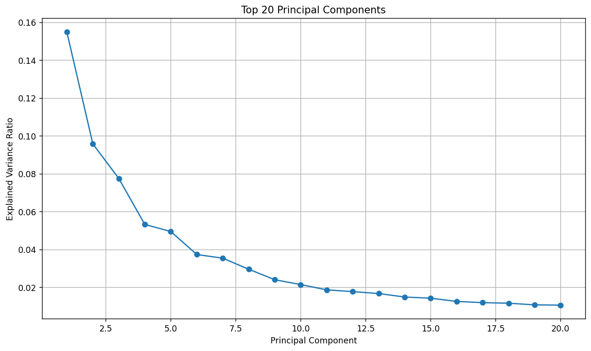
Figure 1. Scree plot of the top 20 principal components. Variance declines gradually after the first few PCs, indicating structure without a sharply discrete low-dimensional phenotype.

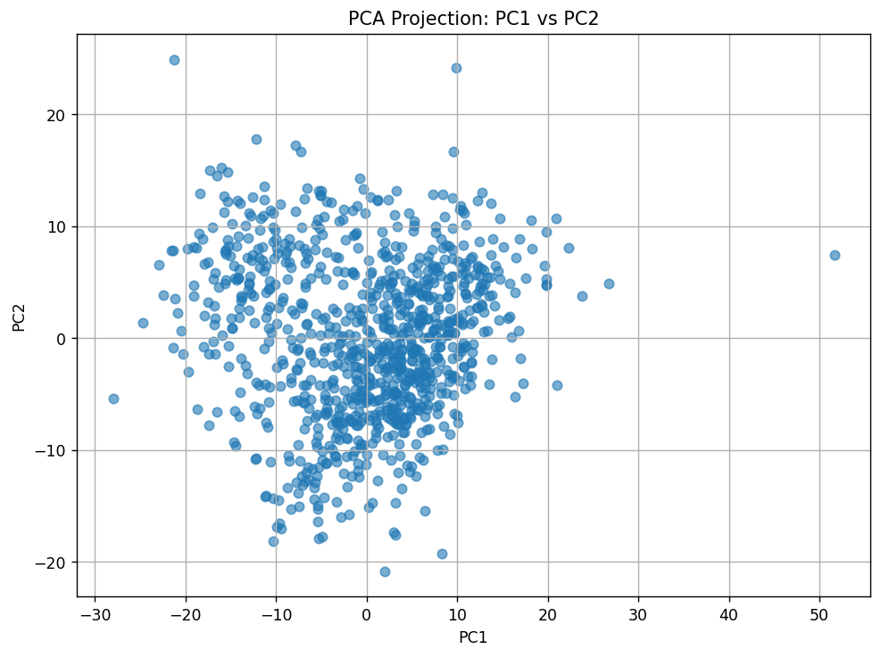
Figure 2. Projection of patients onto PC1 and PC2. The cohort forms a continuous cloud rather than a cleanly separated set of natural subgroups.

Table 4. Internal cluster validity across candidate k values.
k | Silhouette score | Calinski-Harabasz index | Davies-Bouldin index
2 | 0.195653 | 200.929867 | 1.955482
3 | 0.157827 | 179.178568 | 1.932912
4 | 0.146367 | 149.854570 | 1.932116
5 | 0.142494 | 134.423765 | 1.890264
6 | 0.134233 | 122.675314 | 1.864758

Table 5. Bootstrap stability of the raw k=2 phenotype.
Metric | Value
Bootstrap iterations | 20
Subsample fraction | 0.80
Clustering method | K-means
Number of clusters | 2
Feature space | First 10 principal components
Mean ARI | 0.8931
SD ARI | 0.0838
Minimum ARI | 0.7397
Maximum ARI | 0.9837

Table 6. Top raw cluster-separating radiomic features.
Feature | Mean C0 | Mean C1 | C1-C0 | Cohen d | q-value
SER_map_Entropy_tissue_T1 | -0.552 | 0.964 | 1.516 | 2.214 | 1.09E-100
SER_map_sum_entropy_tissue_T1 | -0.552 | 0.963 | 1.515 | 2.211 | 2.70E-109
SER_map_std_dev_tissue_T1 | 0.550 | -0.960 | -1.510 | -2.196 | 2.45E-164
SER_map_difference_entropy_tissue_T1 | -0.546 | 0.953 | 1.499 | 2.162 | 1.18E-103
SER_map_Homogeneity2_tissue_T1 | 0.540 | -0.942 | -1.483 | -2.114 | 2.46E-95
SER_map_Homogeneity1_tissue_T1 | 0.539 | -0.940 | -1.479 | -2.104 | 1.70E-97
PE_map_std_dev_tissue_T1 | 0.532 | -0.927 | -1.459 | -2.047 | 1.72E-164

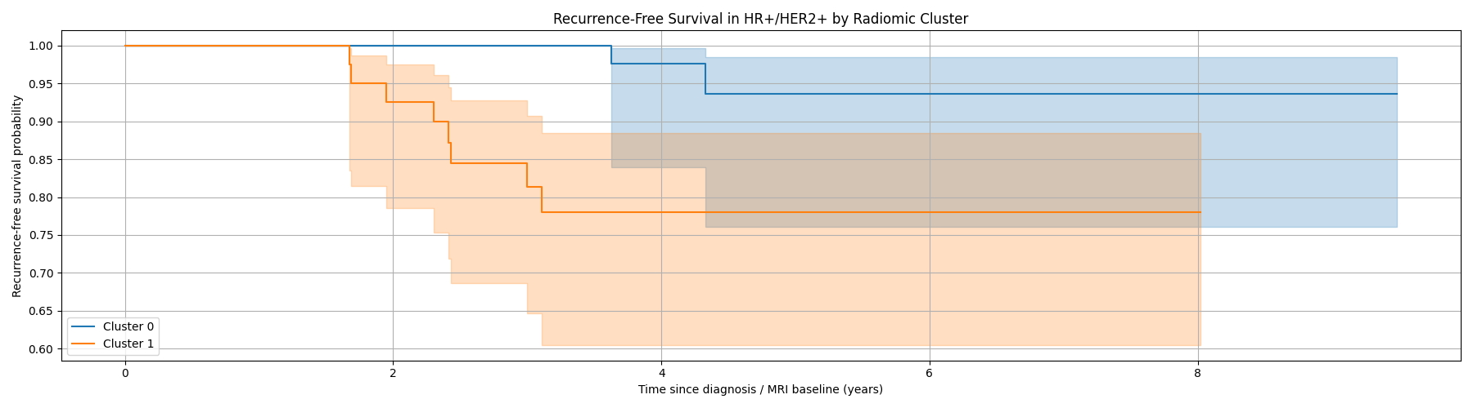
Figure 3. Recurrence-free survival in HR+/HER2+ patients by raw radiomic cluster. The unadjusted analysis shows apparent separation, but the subgroup contains only 10 events.

Table 7. Fragile unadjusted HR+/HER2+ recurrence-free-survival signal by raw radiomic cluster.
Analysis | Estimate | 95% CI | p-value | Interpretation
Cluster 0 | 55 patients; 2 events; event rate 3.6% | - | - | Lower unadjusted recurrence burden.
Cluster 1 | 46 patients; 8 events; event rate 17.4% | - | - | Higher unadjusted recurrence burden; not sufficient for biomarker interpretation.
Log-rank test | - | - | 0.010 | Significant unadjusted RFS difference.
Cox: Cluster 1 vs Cluster 0 | HR=4.76 | 1.22-18.61 | 0.02 | Large but imprecise unadjusted effect based on only 10 events.

4.2 Key message 2: the apparent phenotype is acquisition-dominated, not subtype-defined
The raw phenotype interpretation changes once acquisition variables are examined directly. The raw cluster was strongly associated with manufacturer (p=8.0 x 10^-104) and was not significantly associated with molecular subtype (p=0.146) or whole-cohort recurrence (p=0.766), as summarized in Table 8. The contingency pattern was not subtle: Cluster 0 was dominated by GE examinations, whereas Cluster 1 was dominated by Siemens examinations (Table 9 and Figure 4).
The PCA geometry confirms the same issue. When PC1-PC2 space is colored by raw cluster and by manufacturer, the two displays are nearly interchangeable (Figure 5). This indicates that the clustering algorithm largely recovered the dominant acquisition-domain structure already embedded in the latent space. In the extended technical-variance screen, TR, TE, acquisition matrix, and manufacturer were associated with PC1 far more strongly than molecular subtype, with TR eta-squared approximately 0.76, TE 0.63, acquisition matrix 0.57, and manufacturer 0.49; molecular subtype remained no higher than approximately 0.04 on the top ten PCs (Table 10).
This is the central empirical example of the stability trap. The partition is not noisy; it is stable. The problem is that the stable signal is primarily acquisition-linked. In this setting, high bootstrap ARI is better interpreted as evidence that the scanner-domain structure is reproducible, not as evidence that the clusters are biological.
Table 8. Association of raw cluster assignment with clinical and technical variables.
Variable | p-value | Interpretation
Manufacturer | 8.022438E-104 | Strong association with raw cluster assignment.
Molecular subtype | 0.145796 | No significant association with raw cluster assignment.
Recurrence event | 0.765626 | No significant whole-cohort association with recurrence.

Table 9. Raw cluster assignment by MRI manufacturer.
Cluster | GE | Siemens | Interpretation
0 | 547 | 39 | Cluster 0 is predominantly GE.
1 | 81 | 255 | Cluster 1 is predominantly Siemens.

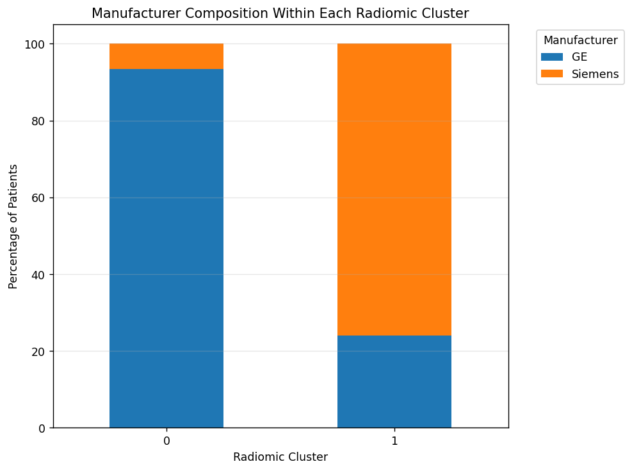
Figure 4. Manufacturer composition within each raw radiomic cluster. The two-cluster solution is largely a GE-versus-Siemens partition.

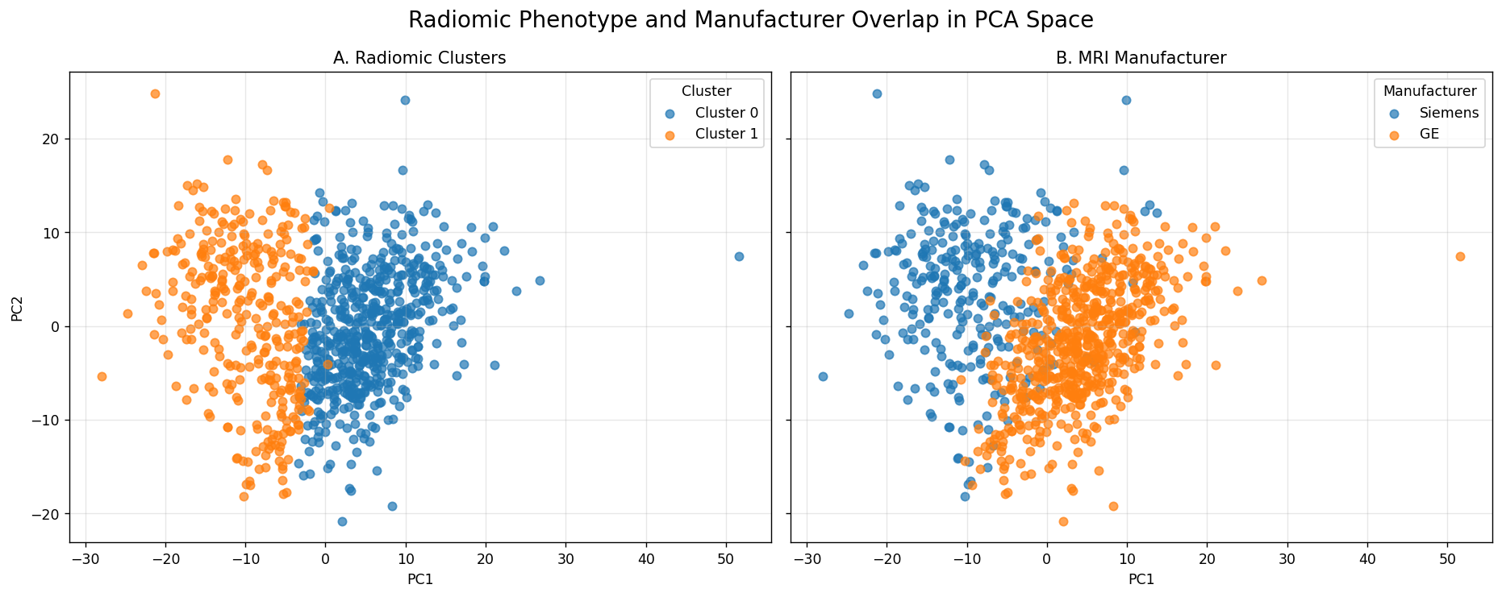
Figure 5. Raw PCA space colored by radiomic cluster and by manufacturer. The visual overlap between panels shows that manufacturer structure closely tracks the raw cluster partition.

Table 10. Acquisition-variable dominance on the leading radiomic axis.
Variable | PC1 eta-squared or association strength | Interpretation
TR | 0.76 | Dominant pulse-sequence association with PC1.
TE | 0.63 | Strong pulse-sequence association with PC1.
Acquisition matrix | 0.57 | Strong technical association with PC1.
Manufacturer | 0.49 | Strong scanner-domain association with PC1.
Field strength | 0.09 | Weaker than TR/TE/manufacturer.
Slice thickness | 0.07 | Weaker than TR/TE/manufacturer.
Molecular subtype | <=0.04 across top-10 PCs | Biological subtype explains much less leading-PC structure.

4.3 Key message 3: harmonization preserves bootstrap stability but destroys partition identity
Residualization and ComBat removed the detectable manufacturer association, but they did not preserve the original phenotype. After manufacturer residualization, the ARI between the residualized labels and the raw labels was 0.056. After ComBat harmonization, ARI versus the raw labels was 0.065. These values indicate near-complete loss of raw partition identity.
The crucial point is that clusterability remained. The residualized and ComBat spaces each produced internally stable two-cluster solutions, with mean bootstrap ARI 0.919 and 0.903 respectively (Table 11 and Figure 7). Figure 6 shows the same conclusion visually: the raw cluster geometry and manufacturer geometry overlap, whereas the residualized cluster geometry no longer reproduces the raw partition.
These findings separate two properties that are often conflated. Bootstrap stability asks whether a cluster solution can be reproduced within a data condition. Partition identity asks whether the same patients remain grouped after technical correction. In this report, stability is preserved while identity collapses. A validation workflow that reports only stability would miss the failure.
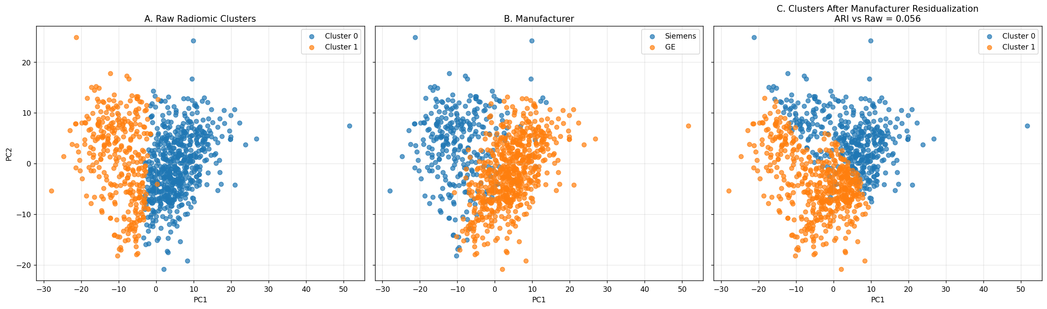
Figure 6. Comparison of latent structure before and after manufacturer residualization. The raw cluster and manufacturer structure overlap, while residualized reclustering produces a different patient partition.

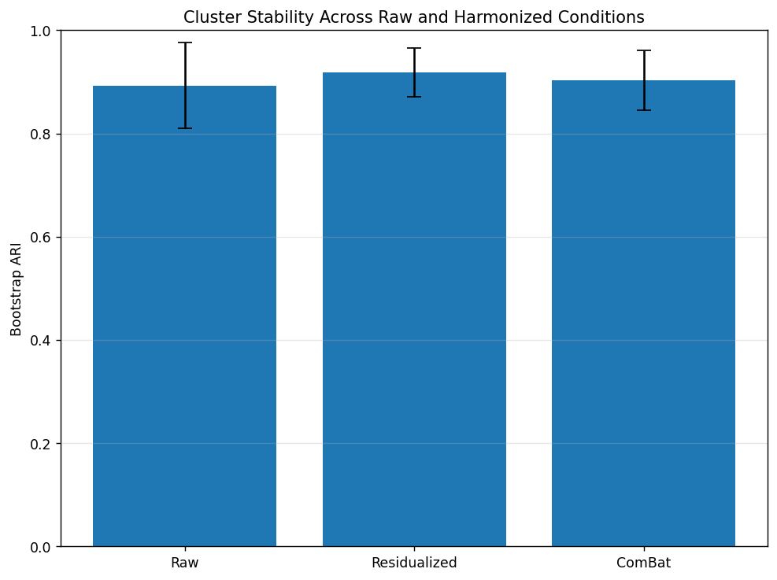
Figure 7. Bootstrap stability across raw and harmonized conditions. All conditions remain internally stable, showing that stability alone does not establish biological identity.

Table 11. Stability versus identity across raw and harmonized conditions.
Condition | Mean bootstrap ARI | SD ARI | ARI versus raw labels | Interpretation
Raw | 0.893139 | 0.083795 | 1.000000 | Stable baseline partition.
Manufacturer residualized | 0.918669 | 0.046946 | 0.056485 | Stable but nearly unrelated to raw labels.
ComBat harmonized | 0.902907 | 0.057623 | 0.064988 | Stable but nearly unrelated to raw labels.

Table 12. Association tests after technical harmonization.
Cluster type | Manufacturer p | Molecular subtype p | Recurrence p | Interpretation
Raw cluster | 8.022438E-104 | 0.145796 | 0.765626 | Strong manufacturer dependence.
Residualized cluster | 0.529964 | 0.716945 | 0.074725 | Manufacturer dependence removed; clinical signal borderline only.
ComBat cluster | 0.176522 | 0.809070 | 0.055758 | Manufacturer dependence attenuated; clinical signal borderline only.

4.4 Key message 4: neither the HR+/HER2+ signal nor the residual size-linked structure supports a biomarker claim
The HR+/HER2+ survival signal should not be framed as a discovery. It is best treated as an unstable warning example. It is based on only 10 events, and the confidence interval around the unadjusted HR is wide. More importantly, the effect attenuates after manufacturer adjustment. In a Cox model including both raw cluster and manufacturer, the cluster HR fell to 2.48 and was no longer significant (95% CI 0.46-13.39; p=0.291). Manufacturer itself was also non-significant in that small subgroup (HR=2.99; p=0.200), but the model is underpowered for two correlated predictors with only 10 events (Table 13).
After technical correction, a residual structure remains, but it is better described as size-linked residue than as a second discovery. In the extended analysis, post-harmonization clusters were no longer detectably manufacturer-coupled and were most strongly associated with tumor bounding-box volume, with p-values on the order of 10^-26. That residual structure did not pass the prespecified biomarker criteria summarized in Table 14: recurrence association was not robust, radiomic scores did not improve recurrence prediction over clinical covariates, and within-vendor direction was not sufficiently reliable to support a biomarker claim.
The result is therefore not that radiomic clustering is useless. The result is that the apparent raw discovery should be downgraded to a failed phenotype claim after acquisition-aware falsification. The defensible conclusion is methodological: stable clusters require identity checks, harmonization sensitivity, and clinical robustness testing before they can be interpreted as phenotypes.
Table 13. Manufacturer-adjusted Cox model in the HR+/HER2+ subgroup.
Covariate | Coefficient | Hazard ratio | 95% CI | p-value | Interpretation
Raw cluster | 0.908162 | 2.479761 | 0.459408-13.385089 | 0.291085 | Cluster effect attenuates and loses significance.
Manufacturer: Siemens vs GE | 1.096711 | 2.994301 | 0.559256-16.031719 | 0.200157 | Non-significant in sparse subgroup; correlated with cluster.

Table 14. Prespecified biomarker criteria for the post-harmonization residual structure.
Criterion | Observed result | Status
Endpoint association | Cluster-level recurrence signals were borderline or non-robust, and adjusted clinical models did not establish a durable recurrence association. | Not met
Incremental predictive value | Radiomic/vascularity-augmented models did not improve recurrence prediction beyond clinical features in nested cross-validation. | Not met
Within-vendor direction consistency | Direction and magnitude were not sufficiently reliable across vendor-restricted analyses to support a biomarker claim. | Not met
Overall conclusion | Residual structure is vendor-cleaner and size-linked, but it is not validated as a biological or clinical phenotype in this cohort. | Fails biomarker threshold

5. Discussion

5.1 Principal finding: the negative result is the result
The main finding is negative and methodological: the raw radiomic phenotype does not survive biological-identity testing. More generally, a radiomic partition can be internally stable, visually coherent, and apparently prognostic while failing to represent a biological subgroup. In this cohort, the raw two-cluster solution looked compelling by standard unsupervised metrics. It was reproducible under bootstrap resampling, had a vascularity-like feature profile, and showed an apparent HR+/HER2+ recurrence-free survival separation. But the strongest signal was alignment with scanner manufacturer and pulse-sequence structure, not molecular subtype or robust recurrence biology.
This is why the term stability trap is useful. The raw phenotype was not a random clustering artifact. It was stable because the acquisition-domain signal was stable. High bootstrap ARI therefore became misleading when interpreted as biological validity. The correct interpretation is narrower: the clustering algorithm reliably recovered a dominant, reproducible structure in the radiomic matrix. The falsification chain shows that this structure was primarily technical, so the strongest result is the invalidation of the phenotype claim rather than the discovery of a phenotype.

5.2 Why the vascularity language must be contained
The cluster-separating features made the raw result plausible. SER entropy, SER homogeneity, PE variability, enhancement-volume ratios, and wash-in/washout descriptors naturally invite a vascularity or perfusion interpretation. In breast DCE-MRI, that interpretation is especially attractive because enhancement behavior is central to the modality. This is exactly what makes the stability trap dangerous: a technically induced partition can still be wrapped in biologically familiar language.
The report therefore does not argue that enhancement features lack biological content. It argues that biological plausibility is not evidence. When the same features are acquisition-sensitive, vascularity language should be treated as a hypothesis pending falsification, not as validation. A vascularity-like label becomes defensible only if the phenotype survives the acquisition-aware checks in Table 1.

5.3 Cluster stability and partition identity are separate validation targets
The harmonization results provide the cleanest methodological lesson. Residualization and ComBat did not eliminate cluster structure; they produced new stable two-cluster partitions. What changed was the identity of the patients in the clusters. The raw-versus-harmonized ARI values near 0.06-0.07 show that the original phenotype did not survive technical correction, even though each corrected dataset remained internally clusterable.
This has direct implications for reporting standards. A radiomic phenotype paper should not stop at silhouette scores, cluster number selection, and bootstrap ARI. It should also report whether cluster labels are preserved after acquisition correction, whether the leading PCs are technical or biological, whether the clinical claim survives harmonization sensitivity, and whether any residual structure meets prespecified biomarker criteria.

5.4 Generalizability: the framework is the portable product
Although the empirical example is breast MRI, the framework is general. Multi-vendor MRI studies of brain tumors, prostate cancer, liver lesions, musculoskeletal imaging, and cardiovascular MRI face the same basic risk: scanner, sequence, site, reconstruction, and protocol variables can define stable latent axes. Multicenter CT, PET, and ultrasound radiomics face analogous problems through kernel, dose, scanner model, reconstruction, uptake timing, and segmentation dependencies.
The same logic applies to imaging AI. A deep representation, self-supervised embedding, or radiomic feature matrix can learn stable site signatures that correlate with outcome because of cohort assembly rather than biology. A high-performing or stable latent subgroup is not automatically a mechanistic phenotype. The proposed falsification chain is aligned with current concerns about reproducibility, transportability, and technical variance in imaging biomarkers: it asks whether the candidate signal remains meaningful when acquisition structure is deliberately challenged.
For that reason, the four checks in Table 1 should be treated as a minimum standard rather than an optional sensitivity appendix. They are inexpensive relative to external validation and can prevent technically stable patterns from being promoted as new biological subtypes.

5.5 Interpretation of the residual size-linked structure
The post-harmonization residual structure should be interpreted conservatively. Removing manufacturer-linked variance revealed a structure more strongly associated with tumor bounding-box volume than with subtype or recurrence. One reading is that harmonization removed the dominant technical axis and left size as the most prominent non-acquisition axis. Another reading is that size is partly a proxy for remaining biological or segmentation-related enhancement structure. The present data cannot adjudicate between those interpretations.
For that reason, the residual structure is not advanced here as a biomarker. It is a failed secondary discovery and a useful negative-control result: harmonization can produce cleaner and still stable partitions, but cleaner does not mean biological. The same biomarker criteria should be applied after harmonization as before harmonization.

5.6 Limitations
Several limitations should be kept in view. First, the HR+/HER2+ survival analysis contains only 10 recurrence events. The unadjusted separation is numerically striking, but the hazard ratio is unstable and the confidence interval is wide. A larger event set would be required to estimate any subtype-specific prognostic effect precisely.
Second, manufacturer is an important but incomplete proxy for technical variation. TR, TE, acquisition matrix, field strength, slice thickness, voxel geometry, coil configuration, reconstruction, and timing may all contribute to radiomic structure. Because many of these variables co-vary, this analysis identifies strong association with technical structure rather than assigning causal responsibility to one parameter.
Third, the analysis uses feature-domain correction rather than image-domain harmonization. Resampling, intensity normalization, standardized reconstruction, and protocol-level harmonization before feature extraction could alter the amount of technical variance entering the radiomic matrix. Those counterfactuals were not available from extracted features alone.
Fourth, k-means in PCA space is transparent and appropriate for a falsification demonstration, but it does not exhaust the space of unsupervised models. Alternative clustering methods could be tested. If the same acquisition-sensitive pattern appears across algorithms, the argument for technical confounding would be stronger.
Finally, harmonization is not ground truth. ComBat and residualization reduce measurable technical effects, but a stable post-harmonization partition is not automatically biological. The falsification framework therefore treats harmonization as a challenge test, not as proof of validity.

6. Conclusion
Conclusion
This study shows that a radiomic phenotype can be internally stable, visually coherent, and apparently prognostic while failing tests of biological identity. In a 922-patient multi-vendor breast MRI cohort, a standard unsupervised workflow produced a stable, vascularity-like two-cluster solution with an apparent HR+/HER2+ survival signal. Acquisition-aware falsification changed the interpretation: leading principal components and raw cluster labels were dominated by manufacturer and pulse-sequence structure; manufacturer adjustment weakened the survival signal; and residualization or ComBat replaced the original patient partition while preserving internal stability.
The strongest and most defensible claim is methodological. Stability should be treated as the beginning of radiomic phenotype validation, not the end. A minimum validation standard should include multi-condition discovery, harmonization sensitivity, within-vendor sanity checks, and continuous vendor-clean scores. This framework is applicable beyond breast MRI to any multicenter or multi-vendor radiomics and imaging-AI setting where technical variance can be stable enough to masquerade as biology.

This report shows that the stable raw radiomic phenotype fails as a biological phenotype in this cohort. In a 922-patient multi-vendor breast MRI cohort, a standard unsupervised workflow produced a stable, vascularity-like two-cluster solution with an apparent but underpowered HR+/HER2+ survival signal. Acquisition-aware falsification changed the interpretation: leading PCs and raw cluster labels were dominated by manufacturer and pulse-sequence structure; manufacturer adjustment weakened the HR+/HER2+ result; and residualization or ComBat replaced the original patient partition while preserving internal stability.
The strongest and most defensible claim is methodological. Stability should be treated as the start of radiomic phenotype validation, not the end. A minimum validation standard should include multi-condition discovery, harmonization sensitivity, within-vendor sanity checks, and continuous vendor-clean scores. This framework is applicable beyond breast MRI to any multicenter or multi-vendor radiomics and imaging-AI setting where technical variance can be stable enough to masquerade as biology.

Supplementary Material

Supplementary Table S1. Interpretation of PCA and cluster visualizations
Supplementary Table S1. Structural interpretation of the raw PCA and clustering outputs.
Item | Interpretation
Scree plot | Variance declines progressively after the first few PCs; structure is present but not concentrated in a single biological axis.
PC1-PC2 scatter | Patients form a continuous distribution without clean natural separation.
Raw k=2 clusters | Cluster separation occurs primarily along the dominant PC axis.
Manufacturer coloring | Manufacturer distribution closely mirrors the raw cluster geometry.
Residualized clusters | Technical correction produces a different stable partition.

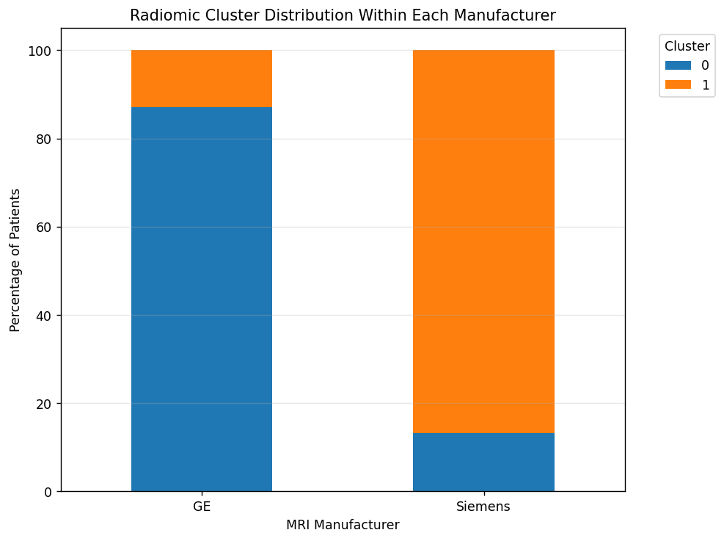
Supplementary Figure S1. Raw radiomic cluster distribution within each manufacturer. GE examinations are mostly assigned to Cluster 0, whereas Siemens examinations are mostly assigned to Cluster 1.

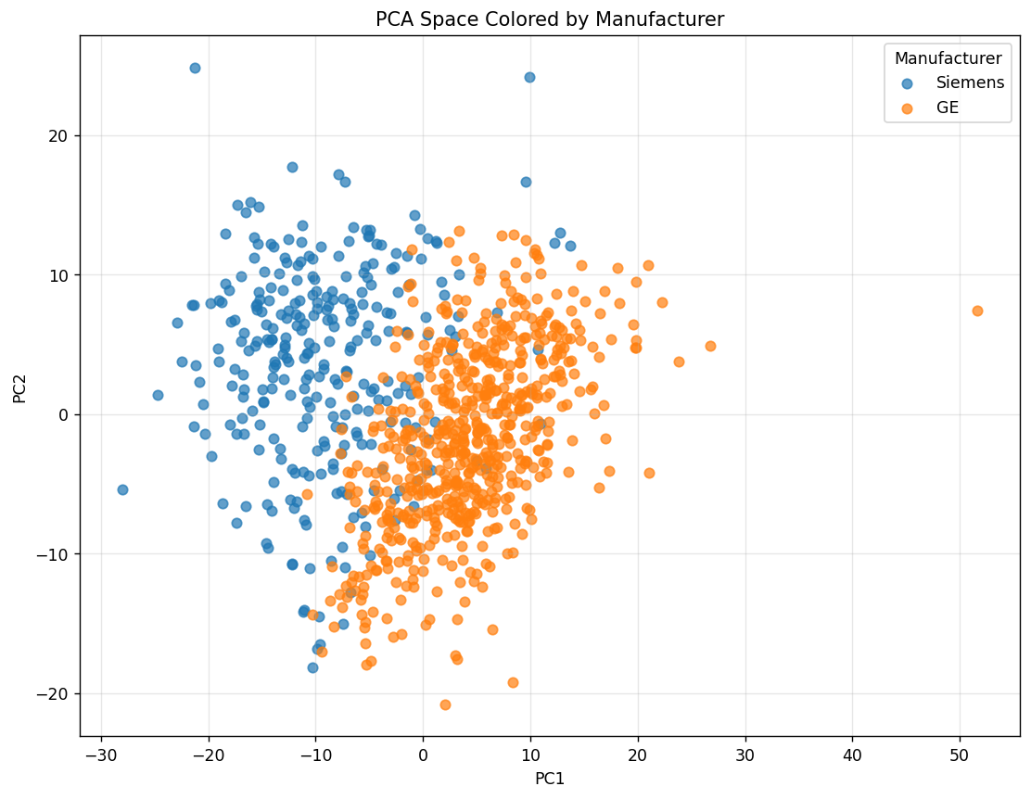
Supplementary Figure S2. PCA space colored by manufacturer. Manufacturer aligns strongly with the dominant latent axis.

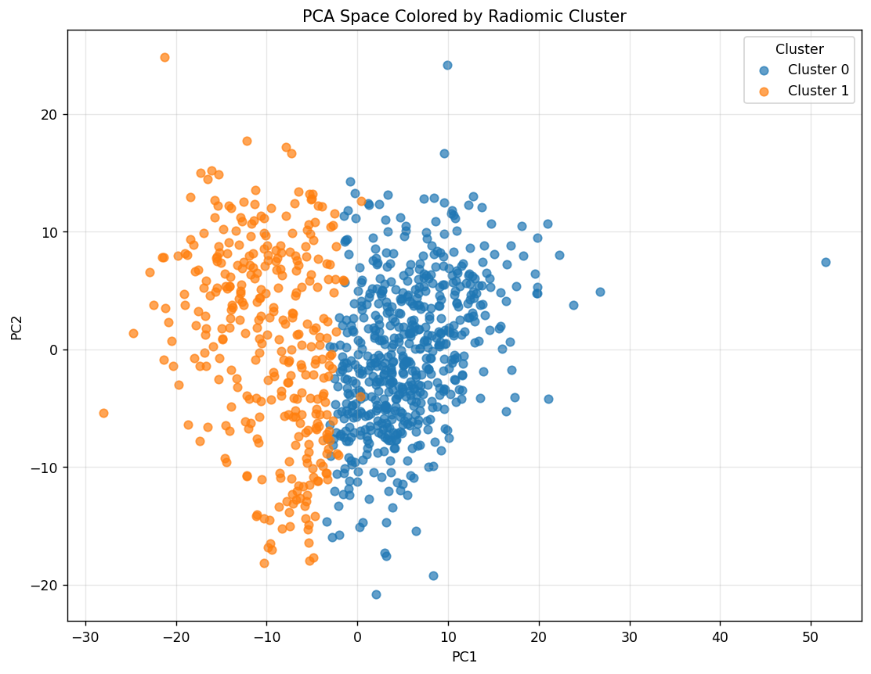
Supplementary Figure S3. PCA space colored by raw radiomic cluster. Cluster geometry closely matches the manufacturer-colored PCA space.

Supplementary Table S2. Raw cluster assignment by molecular subtype.
Cluster | Subtype 0 | Subtype 1 | Subtype 2 | Subtype 3
0 | 383 | 56 | 41 | 106
1 | 212 | 48 | 18 | 58

Supplementary Table S3. Raw cluster assignment by whole-cohort recurrence event.
Cluster | No recurrence | Recurrence
0 | 527 | 57
1 | 306 | 30

Supplementary Table S4. Biological interpretation of dominant feature patterns.
Feature category | Cluster pattern | Interpretation
SER entropy features | Elevated in Cluster 1 | Greater enhancement heterogeneity and spatial disorder.
SER homogeneity features | Elevated in Cluster 0 | More spatially uniform enhancement behavior.
SER standard deviation | Elevated in Cluster 0 | Greater enhancement intensity dispersion in the more homogeneous phenotype.
Enhancement-volume ratios | Strongly cluster-separating | Differences in global vascular enhancement burden.
Wash-in/washout slope features | Strongly cluster-separating | Distinct enhancement kinetics between raw clusters.
Overall phenotype structure | Enhancement-dominant | Putative vascularity-related radiomic phenotype before falsification.

Supplementary Table S5. Claim-status summary after falsification.
Claim | Status in this cohort
Raw two-cluster phenotype is internally stable | Supported by bootstrap ARI.
Raw phenotype has vascularity-like feature appearance | Supported by SER/PE/enhancement-texture feature ranking, but treated only as a plausible counterexample.
Raw phenotype is an independent biological biomarker | Not supported after technical adjudication.
Leading PCs are more technical than subtype-linked | Supported by manufacturer/TR/TE/acquisition-matrix dominance.
Cluster stability and cluster identity are equivalent | Refuted: harmonized partitions remain stable but lose raw identity.
Residual post-harmonization structure is a validated biomarker | Not supported; fails prespecified biomarker criteria.
The framework generalizes beyond breast MRI | Methodologically applicable to multi-vendor and multicenter imaging settings.

List of Main Tables and Figures
Main tables: Table 1, falsification framework; Table 2, preprocessing; Tables 3-7, raw phenotype evidence; Tables 8-10, technical dominance; Tables 11-12, harmonization; Tables 13-14, clinical and biomarker adjudication.
Main figures: Figure 1, scree plot; Figure 2, PC1-PC2 projection; Figure 3, HR+/HER2+ Kaplan-Meier result; Figures 4-5, manufacturer dominance; Figure 6, residualization comparison; Figure 7, stability across raw and harmonized conditions.

References
Lambin, P., Rios-Velazquez, E., Leijenaar, R., Carvalho, S., Van Stiphout, R. G., Granton, P., ... & Aerts, H. J. (2012). Radiomics: extracting more information from medical images using advanced feature analysis. European journal of cancer, 48(4), 441-446.

Zwanenburg, A., Leger, S., Vallières, M., & Löck, S. (2016). Image biomarker standardisation initiative. arXiv preprint arXiv:1612.07003.

Handl, J., Knowles, J., & Kell, D. B. (2005). Computational cluster validation in post-genomic data analysis. Bioinformatics, 21(15), 3201-3212.
Pinker, K., Chin, J., Melsaether, A. N., Morris, E. A., & Moy, L. (2018). Precision medicine and radiogenomics in breast cancer: new approaches toward diagnosis and treatment. Radiology, 287(3), 732-747.

Li, H., Galperin-Aizenberg, M., Pryma, D., Simone II, C. B., & Fan, Y. (2018). Unsupervised machine learning of radiomic features for predicting treatment response and overall survival of early stage non-small cell lung cancer patients treated with stereotactic body radiation therapy. Radiotherapy and Oncology, 129(2), 218-226.

Yamamoto, S., Maki, D. D., Korn, R. L., & Kuo, M. D. (2012). Radiogenomic analysis of breast cancer using MRI: a preliminary study to define the landscape. American Journal of Roentgenology, 199(3), 654-663.

Aerts, H. J., Velazquez, E. R., Leijenaar, R. T., Parmar, C., Grossmann, P., Carvalho, S., ... & Lambin, P. (2014). Decoding tumour phenotype by noninvasive imaging using a quantitative radiomics approach. Nature communications, 5(1), 4006.
Gillies, R. J., Kinahan, P. E., & Hricak, H. (2016). Radiomics: images are more than pictures, they are data. Radiology, 278(2), 563-577.
Parmar, C., Grossmann, P., Rietveld, D., Rietbergen, M. M., Lambin, P., & Aerts, H. J. (2015). Radiomic machine-learning classifiers for prognostic biomarkers of head and neck cancer. Frontiers in oncology, 5, 272.
Park, J. E., Kim, D., Kim, H. S., Park, S. Y., Kim, J. Y., Cho, S. J., ... & Kim, J. H. (2020). Quality of science and reporting of radiomics in oncologic studies: room for improvement according to radiomics quality score and TRIPOD statement. European radiology, 30(1), 523-536.

Berenguer, R., Pastor-Juan, M. D. R., Canales-Vázquez, J., Castro-García, M., Villas, M. V., Mansilla Legorburo, F., & Sabater, S. (2018). Radiomics of CT features may be nonreproducible and redundant: influence of CT acquisition parameters. Radiology, 288(2), 407-415.
Mackin, D., Fave, X., Zhang, L., Fried, D., Yang, J., Taylor, B., ... & Jones, A. K. (2015). Measuring computed tomography scanner variability of radiomics features. Investigative radiology, 50(11), 757-765.
Duron, L., Balvay, D., Vande Perre, S., Bouchouicha, A., Savatovsky, J., Sadik, J. C., ... & Lecler, A. (2019). Gray-level discretization impacts reproducible MRI radiomics texture features. PLoS One, 14(3), e0213459.
Leijenaar, R. T., Nalbantov, G., Carvalho, S., Van Elmpt, W. J., Troost, E. G., Boellaard, R., ... & Lambin, P. (2015). The effect of SUV discretization in quantitative FDG-PET Radiomics: the need for standardized methodology in tumor texture analysis. Scientific reports, 5(1), 11075.
Traverso, A., Wee, L., Dekker, A., & Gillies, R. (2018). Repeatability and reproducibility of radiomic features: a systematic review. International Journal of Radiation Oncology* Biology* Physics, 102(4), 1143-1158.
Nyúl, L. G., & Udupa, J. K. (1999). On standardizing the MR image intensity scale. Magnetic Resonance in Medicine: An Official Journal of the International Society for Magnetic Resonance in Medicine, 42(6), 1072-1081.
Bhooshan, N., Giger, M. L., Jansen, S. A., Li, H., Lan, L., & Newstead, G. M. (2010). Cancerous breast lesions on dynamic contrast-enhanced MR images: computerized characterization for image-based prognostic markers. Radiology, 254(3), 680-690.
Doran, S. J., Kumar, S., Orton, M., d’Arcy, J., Kwaks, F., O’Flynn, E., ... & Koh, D. M. (2021). “Real-world” radiomics from multi-vendor MRI: an original retrospective study on the prediction of nodal status and disease survival in breast cancer, as an exemplar to promote discussion of the wider issues. Cancer Imaging, 21(1), 37.
Johnson, W. E., Li, C., & Rabinovic, A. (2007). Adjusting batch effects in microarray expression data using empirical Bayes methods. Biostatistics, 8(1), 118-127.
Fortin, J. P., Cullen, N., Sheline, Y. I., Taylor, W. D., Aselcioglu, I., Cook, P. A., ... & Shinohara, R. T. (2018). Harmonization of cortical thickness measurements across scanners and sites. Neuroimage, 167, 104-120.

Mayerhoefer, M. E. (2022). Impact of ComBat harmonization on PET radiomics-based tissue classification: a dual-center PET/MRI and PET/CT study. Journal of Nuclear Medicine, 63(10), 1611-1616.
Da-Ano, R., Visvikis, D., & Hatt, M. (2020). Harmonization strategies for multicenter radiomics investigations. Physics in Medicine & Biology, 65(24), 24TR02.
Lozano-Montoya, J., & Jimenez-Pastor, A. (2024). Harmonization in the Features Domain. In Basics of Image Processing: The Facts and Challenges of Data Harmonization to Improve Radiomics Reproducibility (pp. 145-166). Cham: Springer International Publishing.
Collins, G. S., Reitsma, J. B., Altman, D. G., & Moons, K. G. (2015). Transparent reporting of a multivariable prediction model for individual prognosis or diagnosis (TRIPOD): the TRIPOD statement. Journal of British Surgery, 102(3), 148-158.
Lu, L., Ahmed, F. S., Akin, O., Luk, L., Guo, X., Yang, H., ... & Zhao, B. (2021). Uncontrolled confounders may lead to false or overvalued radiomics signature: a proof of concept using survival analysis in a multicenter cohort of kidney cancer. Frontiers in Oncology, 11, 638185.

